Selected Test Cases
Python Programs with Algorithm, Pseudocode, Flowchart and Source Code
Contents
- Case 91: Advanced String-Based Registration Record Analyzer
- Case 86: Multi-Stage ATM Transaction Audit
- Case 75: Integrated Student Record Consistency Checker
- Case 98: University Academic Progression Audit
- Case 82: Multi-Criteria Internship Candidate Ranking
- Case 70: Multi-Stage Scholarship Shortlisting
- Case 65: Campus Resource Allocation Under Constraints
- Case 89: University Hostel Room Allocation
- Case 52: Hackathon Team Formation and Ranking
- Case 79: Integrated Warehouse Order Prioritization

Case 91: Advanced String-Based Registration Record Analyzer

Problem Statement
Validate a registration ID in the format YYYYBRRNNN: four digits for admission year, three uppercase letters for branch, and three digits for roll number. Display the extracted parts if valid.

Objectives
Practice string length, indexing/slicing, conditions, and input/output.

Assumptions
The required format is exactly 10 characters. Example: 2026CSE012. Branch is three uppercase letters; year and roll number are digits.

Algorithm
- Read the registration ID.
- Check that its length is 10.
- Check that the first four and last three characters are digits.
- Check that the three branch characters are uppercase letters.
- If all checks pass, display year, branch, and roll number; otherwise display invalid.

Pseudocode
START
INPUT registration_id
IF length is not 10: PRINT Invalid
ELSE IF year part or roll part is not numeric: PRINT Invalid
ELSE IF branch part is not uppercase letters: PRINT Invalid
ELSE: PRINT year, branch, roll number
STOP

Flowchart
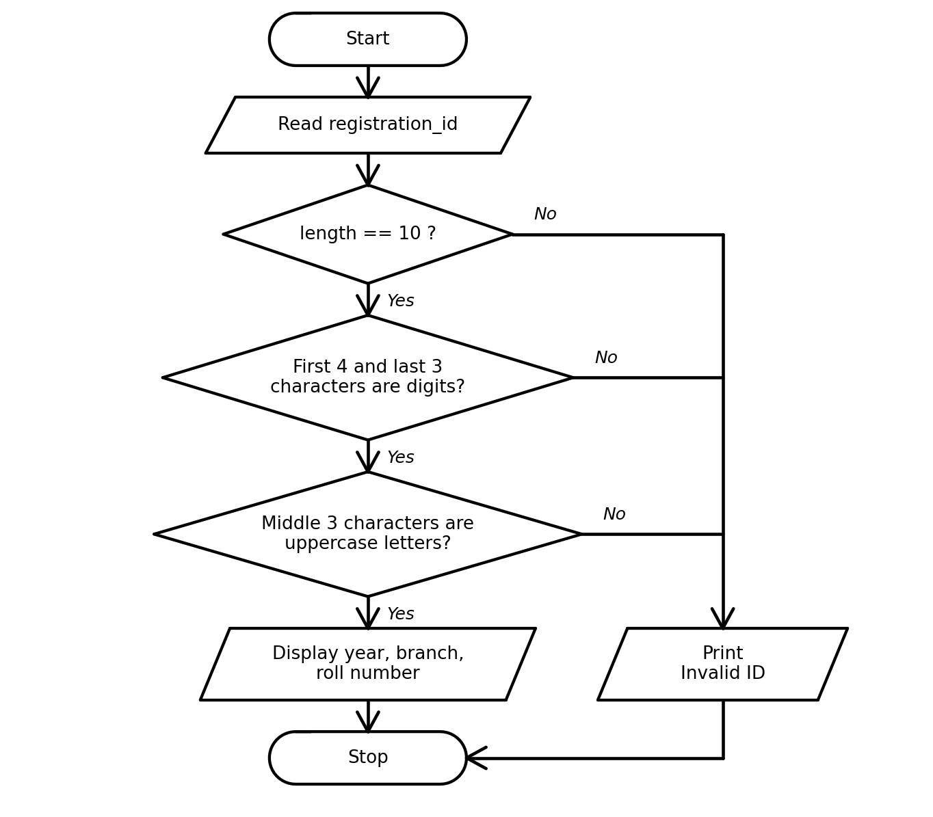

Python Source Code
registration_id = input("Enter registration ID (YYYYBRRNNN): ").strip()
if len(registration_id) != 10:
print("Invalid registration ID")
elif not (registration_id[0:4].isdigit() and registration_id[7:10].isdigit()):
print("Invalid registration ID")
elif not (registration_id[4:7].isalpha() and registration_id[4:7].isupper()):
print("Invalid registration ID")
else:
print("Valid registration ID")
print("Year:", registration_id[0:4])
print("Branch:", registration_id[4:7])
print("Roll number:", registration_id[7:10])

Test Cases
Test input / condition | Expected result
2026CSE012 | Valid; year 2026, branch CSE, roll 012
26CSE012 | Invalid registration ID
2026cse012 | Invalid registration ID

Program Output
"C:\Users\student\PycharmProjects\pythonProject\.venv\Scripts\python.exe" "C:\Users\student\PycharmProjects\pythonProject\text cases\case1.py"
Enter registration ID (YYYYBRRNNN): 2026CSE012
Valid registration ID
Year: 2026
Branch: CSE
Roll number: 012

Process finished with exit code 0

"C:\Users\student\PycharmProjects\pythonProject\.venv\Scripts\python.exe" "C:\Users\student\PycharmProjects\pythonProject\text cases\case1.py"
Enter registration ID (YYYYBRRNNN): 26CSE012
Invalid registration ID

Process finished with exit code 0

"C:\Users\student\PycharmProjects\pythonProject\.venv\Scripts\python.exe" "C:\Users\student\PycharmProjects\pythonProject\text cases\case1.py"
Enter registration ID (YYYYBRRNNN): 2026cse012
Invalid registration ID

Process finished with exit code 0

Conclusion
The program validates a structured ID and extracts its components using basic string operations.

Case 86: Multi-Stage ATM Transaction Audit

Problem Statement
Process a sequence of deposits and withdrawals, update an account balance, reject invalid withdrawals, and show the final balance.

Objectives
Use tuples, tuple unpacking, loops, conditions, and arithmetic operators.

Assumptions
Transactions are represented as (type, amount). D means deposit and W means withdrawal. Starting balance is Rs. 1,000.

Algorithm
- Set the starting balance to 1000.
- Read each transaction tuple and unpack its type and amount.
- For a valid positive deposit, add the amount.
- For a withdrawal, subtract only if the amount is positive and does not exceed the balance.
- Report invalid transactions and print the final balance.

Pseudocode
START
balance ← 1000
FOR each (type, amount) in transactions
IF amount <= 0: report invalid
ELSE IF type = D: add amount
ELSE IF type = W AND amount <= balance: subtract amount
ELSE IF type = W: report insufficient balance
ELSE: report unknown transaction
PRINT balance
STOP

Flowchart
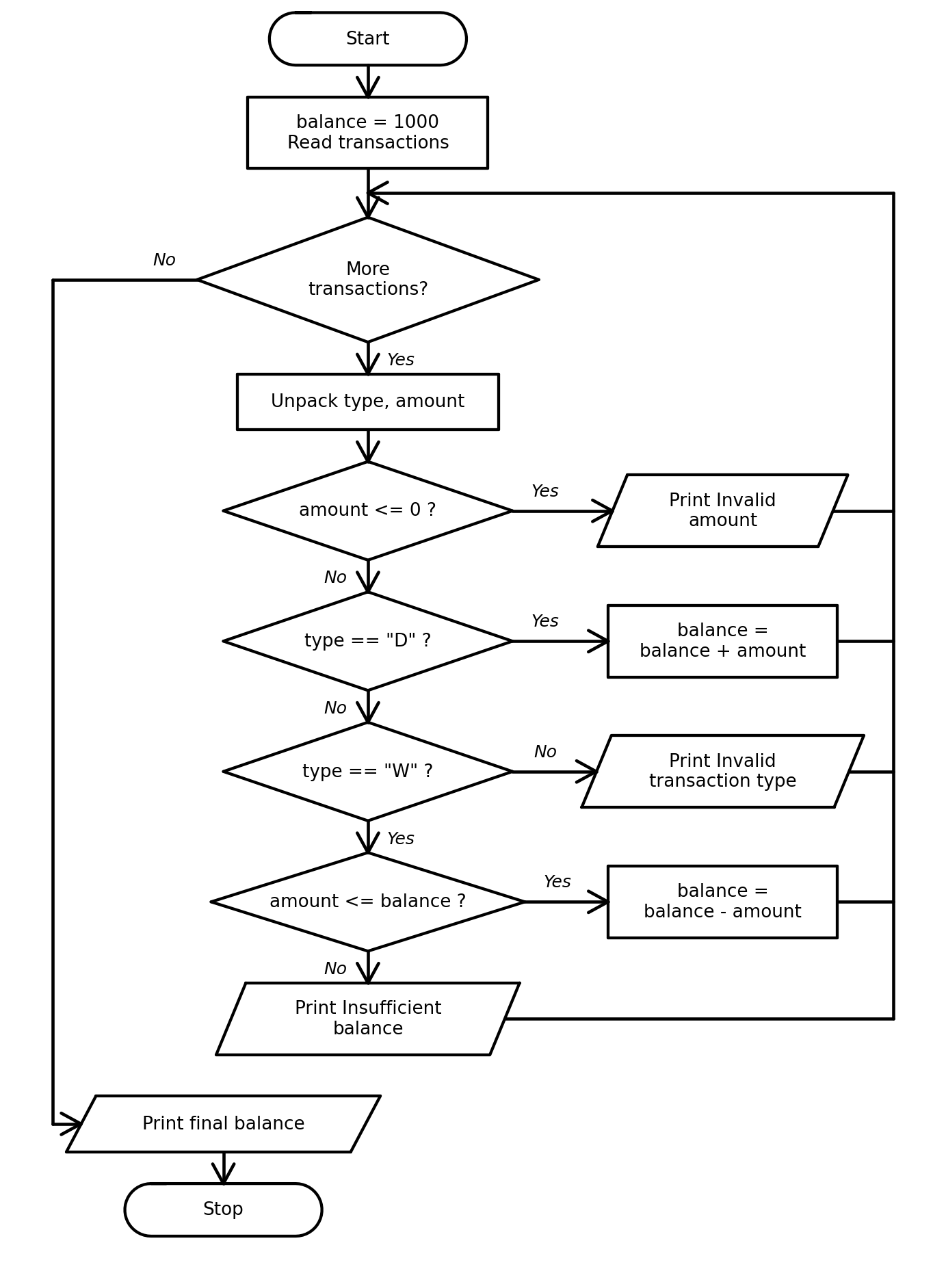

Python Source Code
balance = 1000
transactions = [("D", 500), ("W", 200), ("W", 2000), ("X", 100), ("D", 300)]
for transaction in transactions:
transaction_type, amount = transaction
print(transaction_type, amount, end=": ")
if amount <= 0:
print("Invalid amount")
elif transaction_type == "D":
balance = balance + amount
print("Deposit accepted")
elif transaction_type == "W":
if amount <= balance:
balance = balance - amount
print("Withdrawal accepted")
else:
print("Insufficient balance")
else:
print("Invalid transaction type")
print("Final balance: Rs.", balance)

Test Cases
Test input / condition | Expected result
D 500 | Balance increases by Rs. 500
W 2000 when balance is Rs. 1300 | Withdrawal rejected
X 100 | Unknown transaction type rejected

Program Output
"C:\Users\student\PycharmProjects\pythonProject\.venv\Scripts\python.exe" "C:\Users\student\PycharmProjects\pythonProject\text cases\case2.py"
D 500: Deposit accepted
W 200: Withdrawal accepted
W 2000: Insufficient balance
X 100: Invalid transaction type
D 300: Deposit accepted
Final balance: Rs. 1600

Process finished with exit code 0

Conclusion
The program audits transactions using tuples and prevents withdrawals that exceed the available balance.

Case 75: Integrated Student Record Consistency Checker

Problem Statement
Check student records for duplicate IDs and marks outside the permitted range.

Objectives
Use parallel lists, list traversal, loops, conditions, and comparisons.

Assumptions
Marks must be from 0 to 100. Student IDs must be unique. Sample data is included in the program.

Algorithm
- Store student IDs, names, and marks in lists.
- Visit each student record.
- Check whether the ID appeared earlier in the ID list.
- Check whether marks are between 0 and 100.
- Print any detected issue.

Pseudocode
START
Store IDs, names, marks
FOR each index i
IF ID at i appears earlier: report duplicate ID
IF marks at i < 0 OR marks at i > 100: report invalid marks
STOP

Flowchart
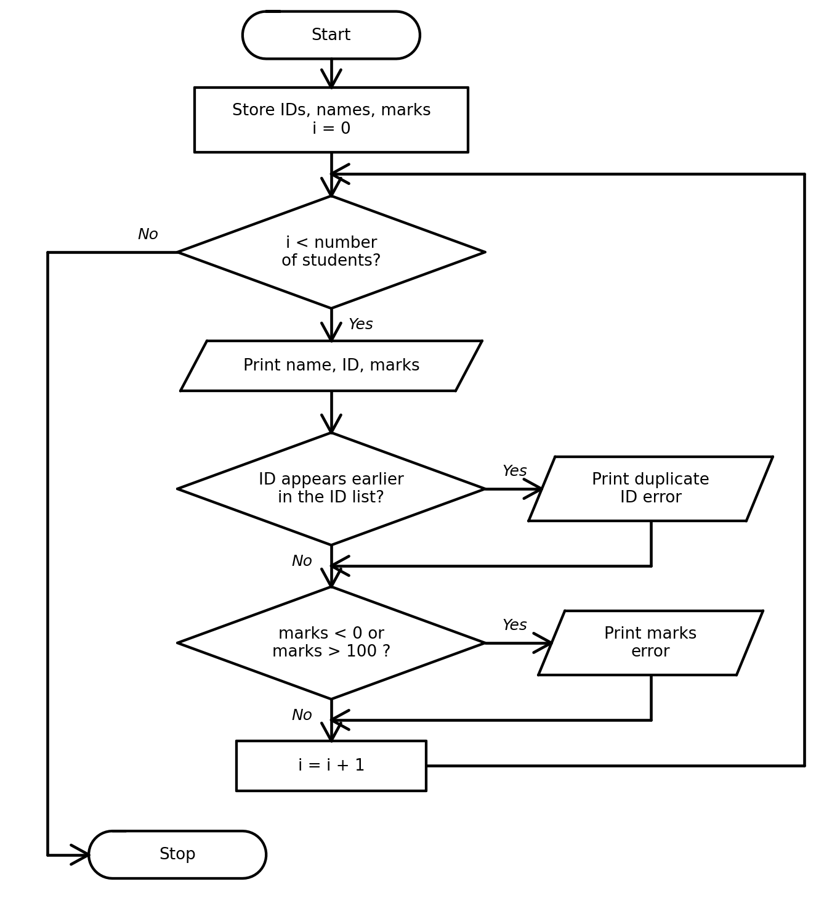

Python Source Code
student_ids = ["S101", "S102", "S101", "S104"]
names = ["Anu", "Ravi", "Meena", "Kiran"]
marks = [85, 72, 91, 108]
for i in range(len(student_ids)):
print(names[i], student_ids[i], marks[i])
if student_ids[i] in student_ids[:i]:
print(" Error: duplicate student ID")
if marks[i] < 0 or marks[i] > 100:
print(" Error: marks must be between 0 and 100")

Test Cases
Test input / condition | Expected result
S101 occurs twice | Second S101 is flagged as duplicate
Kiran has 108 marks | Invalid marks are reported
Ravi has 72 marks | No error reported

Program Output
"C:\Users\student\PycharmProjects\pythonProject\.venv\Scripts\python.exe" "C:\Users\student\PycharmProjects\pythonProject\text cases\case3.py"
Anu S101 85
Ravi S102 72
Meena S101 91
Error: duplicate student ID
Kiran S104 108
Error: marks must be between 0 and 100

Process finished with exit code 0

Conclusion
The program identifies duplicate IDs and invalid marks using list operations and conditions.

Case 98: University Academic Progression Audit

Problem Statement
Determine whether each student can progress to the next semester based on marks, attendance, and prerequisite completion.

Objectives
Apply nested conditions and list traversal to academic eligibility.

Assumptions
A student needs marks of at least 40, attendance of at least 75%, and completed prerequisites. These thresholds are sample rules.

Algorithm
- Store each student's name, marks, attendance, and prerequisite status in a nested list.
- Visit each student record.
- Check all three eligibility conditions.
- Display eligible or not eligible, including the reason when a condition fails.

Pseudocode
START
FOR each student record
eligible ← true
IF marks < 40: print marks requirement; eligible ← false
IF attendance < 75: print attendance requirement; eligible ← false
IF prerequisite is not completed: print prerequisite requirement; eligible ← false
IF eligible: print Eligible
ELSE: print Not eligible
STOP

Flowchart
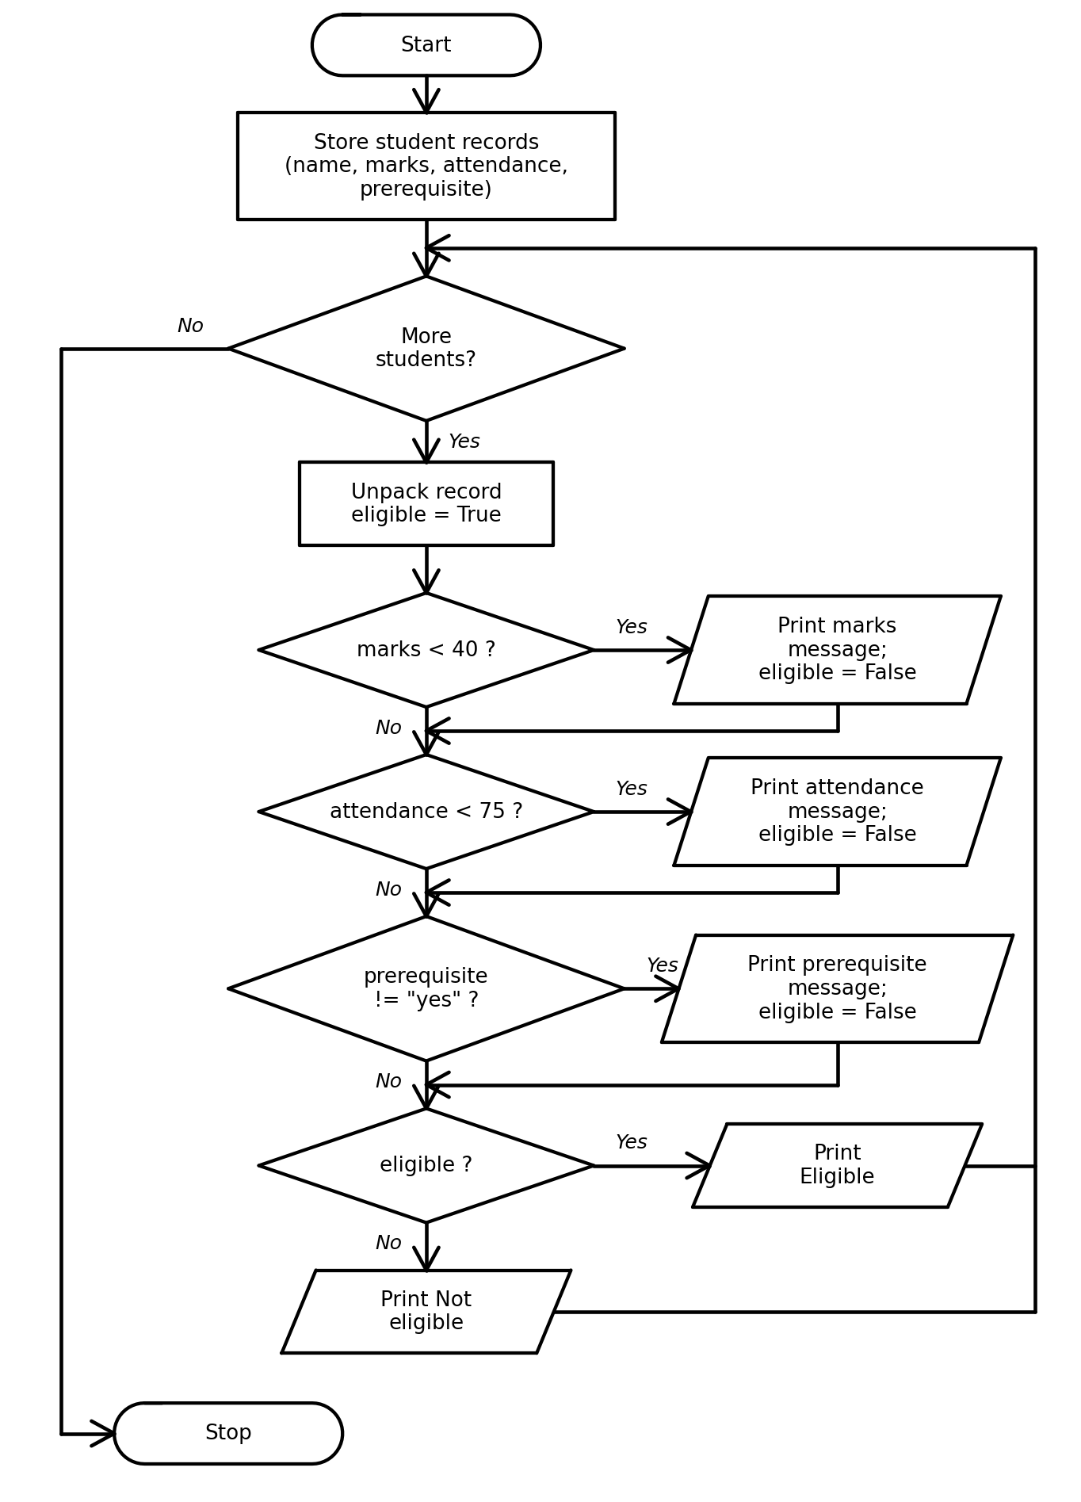

Python Source Code
students = [
["Anu", 72, 88, "yes"],
["Ravi", 35, 80, "yes"],
["Meena", 68, 70, "no"]
]
for student in students:
name, marks, attendance, prerequisite = student
eligible = True
print(name + ":")
if marks < 40:
print(" Marks below 40")
eligible = False
if attendance < 75:
print(" Attendance below 75%")
eligible = False
if prerequisite != "yes":
print(" Prerequisite not completed")
eligible = False
if eligible:
print(" Eligible for next semester")
else:
print(" Not eligible for next semester")

Test Cases
Test input / condition | Expected result
Anu: 72 marks, 88% attendance, prerequisite yes | Eligible
Ravi: 35 marks | Not eligible: marks below 40
Meena: 70% attendance and prerequisite no | Not eligible for both reasons

Program Output
"C:\Users\student\PycharmProjects\pythonProject\.venv\Scripts\python.exe" "C:\Users\student\PycharmProjects\pythonProject\text cases\case4.py"
Anu:
Eligible for next semester
Ravi:
Marks below 40
Not eligible for next semester
Meena:
Attendance below 75%
Prerequisite not completed
Not eligible for next semester

Process finished with exit code 0

Conclusion
The program audits academic progression using nested lists, tuple unpacking, and conditional statements.

Case 82: Multi-Criteria Internship Candidate Ranking

Problem Statement
Select eligible internship candidates and rank them by combined academic and assessment scores.

Objectives
Use tuples, lists, loops, eligibility conditions, and simple sorting.

Assumptions
Eligibility requires academic marks of at least 60 and attendance of at least 75%. Combined score is marks plus assessment score. Higher combined score ranks first.

Algorithm
- Store each candidate as a tuple of name, marks, assessment, and attendance.
- Keep only candidates who meet both eligibility conditions.
- Calculate each eligible candidate's combined score.
- Sort eligible candidates by score from highest to lowest using nested loops.
- Display the ranking.

Pseudocode
START
Create candidate list
Create empty eligible list
FOR each candidate
IF marks >= 60 AND attendance >= 75: add candidate with combined score
FOR each pair of eligible candidates
IF earlier score < later score: swap them
Display ranked list
STOP

Flowchart
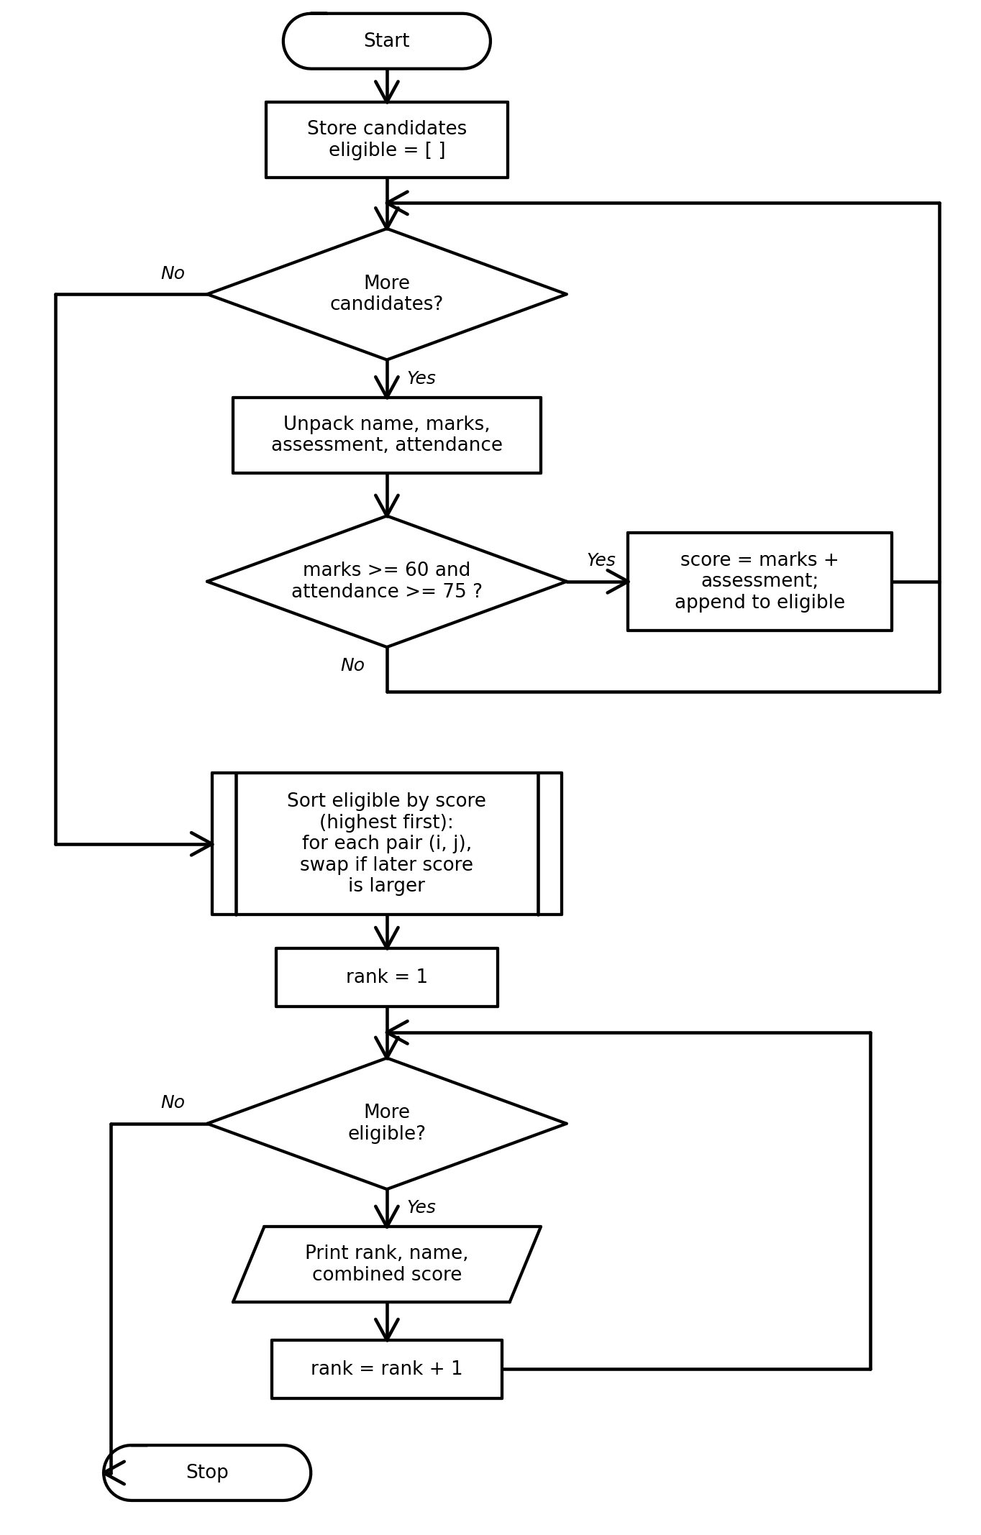

Python Source Code
candidates = [
("Anu", 82, 14, 90),
("Ravi", 75, 18, 80),
("Meena", 55, 20, 92),
("Kiran", 88, 10, 78)
]
eligible = []
for name, marks, assessment, attendance in candidates:
if marks >= 60 and attendance >= 75:
eligible.append((name, marks, assessment, attendance, marks + assessment))
for i in range(len(eligible)):
for j in range(i + 1, len(eligible)):
if eligible[j][4] > eligible[i][4]:
eligible[i], eligible[j] = eligible[j], eligible[i]
rank = 1
for name, marks, assessment, attendance, score in eligible:
print(rank, name, "Combined score:", score)
rank = rank + 1

Test Cases
Test input / condition | Expected result
Meena: 55 marks | Excluded because marks are below 60
Anu score 96; Kiran score 98 | Kiran ranks before Anu
Ravi score 93 | Ranks third

Program Output
"C:\Users\student\PycharmProjects\pythonProject\.venv\Scripts\python.exe" "C:\Users\student\PycharmProjects\pythonProject\text cases\case5.py"
1 Kiran Combined score: 98
2 Anu Combined score: 96
3 Ravi Combined score: 93

Process finished with exit code 0

Conclusion
The program filters eligible candidates and ranks them with loops and tuple data.

Case 70: Multi-Stage Scholarship Shortlisting

Problem Statement
Shortlist students for a limited number of scholarships using marks, attendance, and family income.

Objectives
Practise multiple eligibility conditions, tuple unpacking, list operations, and ranking.

Assumptions
Eligibility requires marks ≥ 80, attendance ≥ 85%, and annual family income ≤ Rs. 300,000. Only the top two eligible students receive scholarships.

Algorithm
- Store applicant details as tuples.
- Select applicants meeting all three conditions.
- Sort eligible applicants by marks in descending order.
- Award scholarships to the first two applicants.
- Display selected students and any remaining eligible applicants.

Pseudocode
START
Create applicants list
eligible ← empty list
FOR each applicant
IF marks >= 80 AND attendance >= 85 AND income <= 300000: append applicant
Sort eligible by marks descending
Display first two as selected
Display remaining eligible applicants as waiting list
STOP

Flowchart
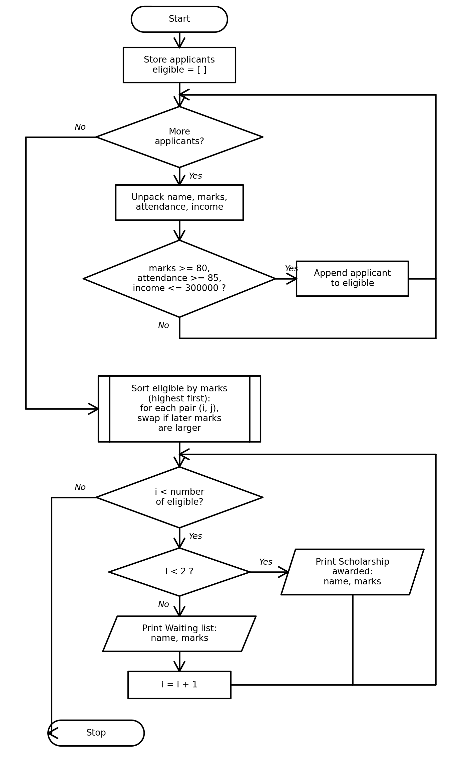

Python Source Code
applicants = [
("Anu", 91, 92, 250000),
("Ravi", 84, 88, 280000),
("Meena", 95, 90, 400000),
("Kiran", 87, 86, 200000)
]
eligible = []
for name, marks, attendance, income in applicants:
if marks >= 80 and attendance >= 85 and income <= 300000:
eligible.append((name, marks, attendance, income))
for i in range(len(eligible)):
for j in range(i + 1, len(eligible)):
if eligible[j][1] > eligible[i][1]:
eligible[i], eligible[j] = eligible[j], eligible[i]
for i in range(len(eligible)):
if i < 2:
print("Scholarship awarded:", eligible[i][0], eligible[i][1])
else:
print("Waiting list:", eligible[i][0], eligible[i][1])

Test Cases
Test input / condition | Expected result
Meena has income Rs. 400000 | Not eligible
Anu and Kiran meet all rules | Shortlisted based on marks
Ravi meets rules but has lower marks | Placed on the waiting list

Program Output
"C:\Users\student\PycharmProjects\pythonProject\.venv\Scripts\python.exe" "C:\Users\student\PycharmProjects\pythonProject\text cases\case6.py"
Scholarship awarded: Anu 91
Scholarship awarded: Kiran 87
Waiting list: Ravi 84

Process finished with exit code 0

Conclusion
The program applies three scholarship conditions and shortlists candidates within a fixed quota.

Case 65: Campus Resource Allocation Under Constraints

Problem Statement
Compare required equipment with available quantities and report how much can be allocated and what shortage remains.

Objectives
Use nested lists, arithmetic, loops, and conditional statements.

Assumptions
Each activity receives up to its requested quantity. Available stock cannot be exceeded. Activities are processed in the listed priority order.

Algorithm
- Store activity, available quantity, and required quantity in a nested list.
- For each activity, allocate the smaller of available and required quantities.
- Calculate the shortage as required minus allocated.
- Display allocation and shortage.

Pseudocode
START
FOR each activity, available, required
IF available < required: allocated ← available
ELSE: allocated ← required
shortage ← required - allocated
PRINT activity, allocated, shortage
STOP

Flowchart
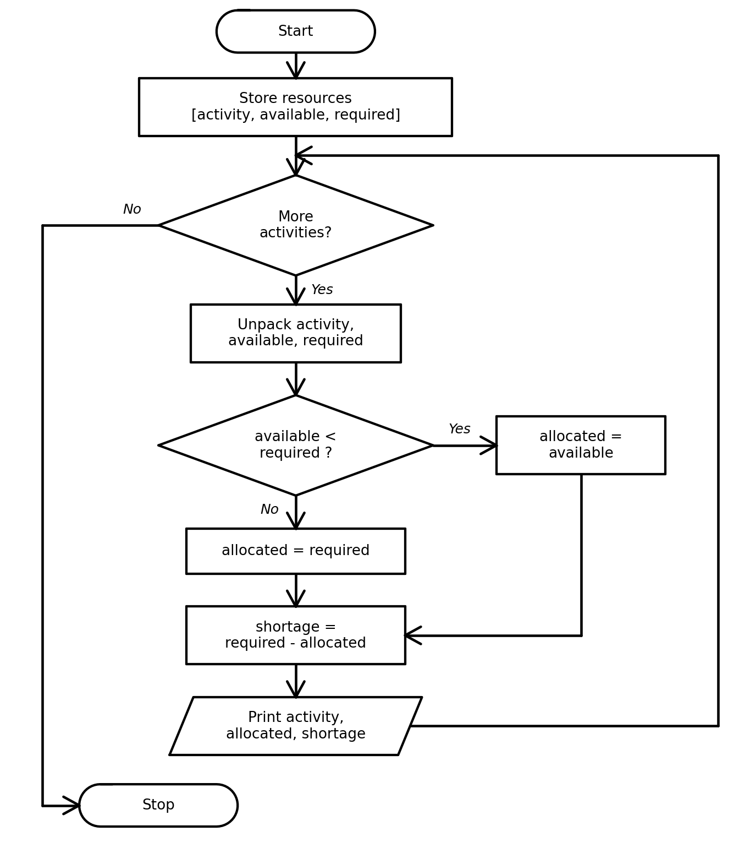

Python Source Code
resources = [
["Robotics club", 8, 6],
["Science fair", 5, 7],
["Coding event", 10, 10],
["Art club", 2, 4]
]
for resource in resources:
activity, available, required = resource
if available < required:
allocated = available
else:
allocated = required
shortage = required - allocated
print(activity, "| Allocated:", allocated, "| Shortage:", shortage)

Test Cases
Test input / condition | Expected result
Robotics: available 8, required 6 | Allocate 6; shortage 0
Science fair: available 5, required 7 | Allocate 5; shortage 2
Coding event: available 10, required 10 | Allocate 10; shortage 0

Program Output
"C:\Users\student\PycharmProjects\pythonProject\.venv\Scripts\python.exe" "C:\Users\student\PycharmProjects\pythonProject\text cases\case7.py"
Robotics club | Allocated: 6 | Shortage: 0
Science fair | Allocated: 5 | Shortage: 2
Coding event | Allocated: 10 | Shortage: 0
Art club | Allocated: 2 | Shortage: 2

Process finished with exit code 0

Conclusion
The program calculates feasible allocations without exceeding available resources.

Case 89: University Hostel Room Allocation

Problem Statement
Assign students to hostel rooms while respecting each room's capacity and report any students who cannot be accommodated.

Objectives
Use lists, nested loops, counters, and conditions.

Assumptions
Students are allocated in the order listed. Rooms are filled one at a time according to the capacity list. Each room has a fixed capacity.

Algorithm
- Store student names and room capacities in lists.
- Start from the first student.
- Use a loop to fill each room up to its capacity.
- Display the students assigned to each room.
- Report any students left unallocated.

Pseudocode
START
student_index ← 0
FOR each room capacity
assigned ← 0
WHILE assigned < capacity AND students remain
PRINT room and current student
advance student_index and assigned
IF students remain: print unallocated students
STOP

Flowchart
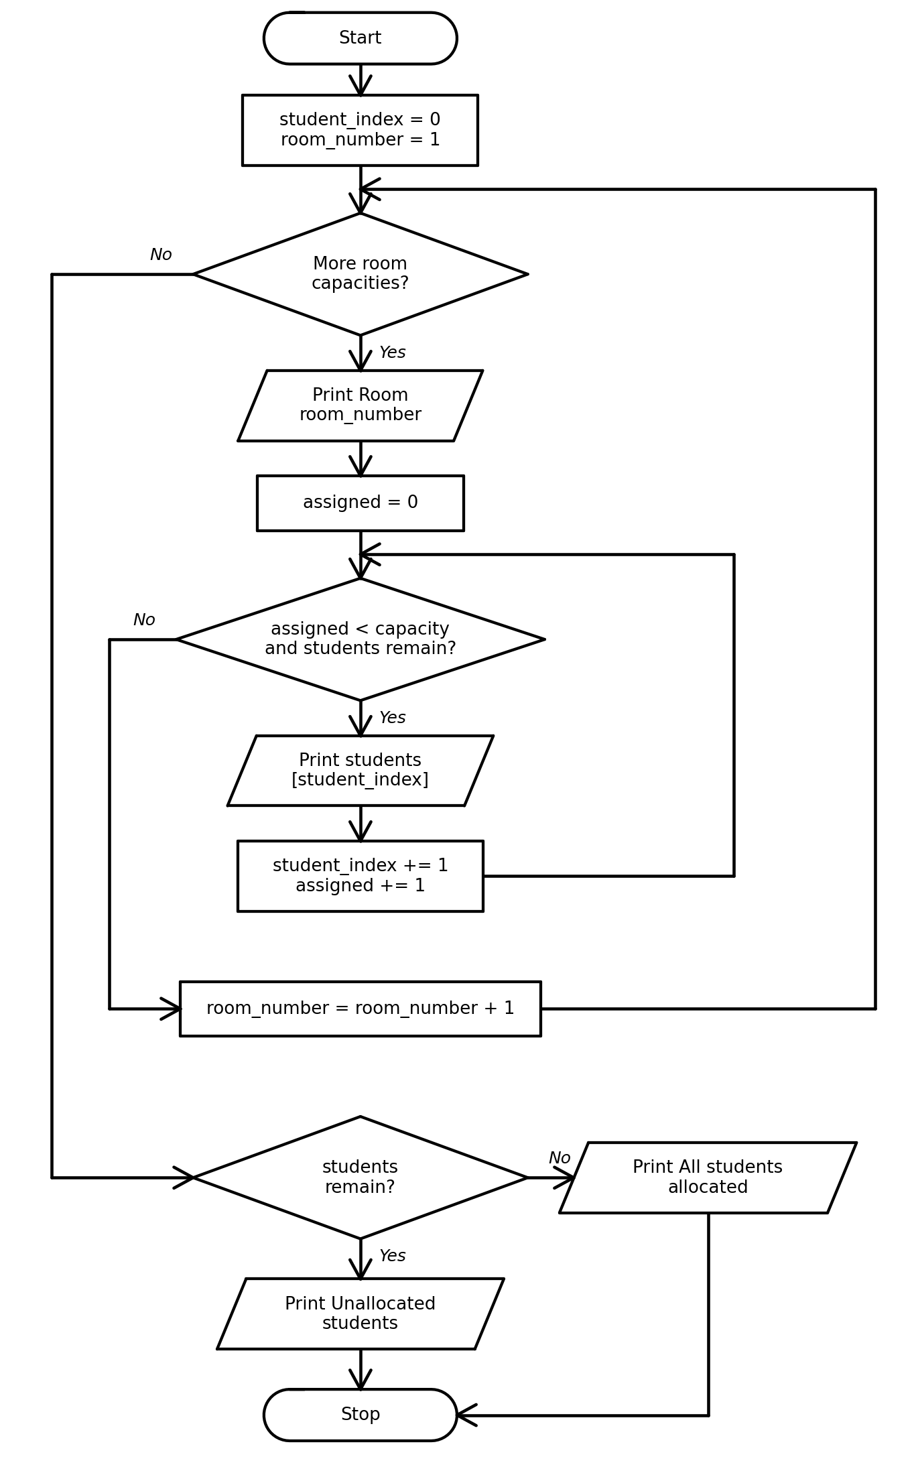

Python Source Code
students = ["Anu", "Ravi", "Meena", "Kiran", "Divya", "Arjun", "Sara"]
capacities = [2, 3, 1]
student_index = 0
room_number = 1
for capacity in capacities:
print("Room", room_number, ":")
assigned = 0
while assigned < capacity and student_index < len(students):
print(" ", students[student_index])
student_index = student_index + 1
assigned = assigned + 1
room_number = room_number + 1
if student_index < len(students):
print("Unallocated students:")
for i in range(student_index, len(students)):
print(students[i])
else:
print("All students allocated")

Test Cases
Test input / condition | Expected result
7 students; capacities 2, 3, 1 | 6 students allocated; 1 unallocated
5 students; capacities 2, 3 | All students allocated
No remaining students | No unallocated list shown

Program Output
"C:\Users\student\PycharmProjects\pythonProject\.venv\Scripts\python.exe" "C:\Users\student\PycharmProjects\pythonProject\text cases\case8.py"
Room 1 :
Anu
Ravi
Room 2 :
Meena
Kiran
Divya
Room 3 :
Arjun
Unallocated students:
Sara

Process finished with exit code 0

Conclusion
The program allocates students sequentially and reports demand that exceeds total room capacity.

Case 52: Hackathon Team Formation and Ranking

Problem Statement
Calculate total scores for teams from two rounds and rank the teams by total score.

Objectives
Use nested lists, loops, arithmetic, comparisons, and swapping list elements.

Assumptions
Each team has two round scores. Total score is the sum of both rounds. Higher total score ranks first.

Algorithm
- Store each team's name and two round scores in a nested list.
- Calculate and append each team's total score.
- Compare totals using nested loops and swap records when needed.
- Display the ranked teams.

Pseudocode
START
FOR each team record
total ← round1 + round2
append total to record
FOR each pair of teams
IF second total > first total: swap records
Display ranked teams
STOP

Flowchart
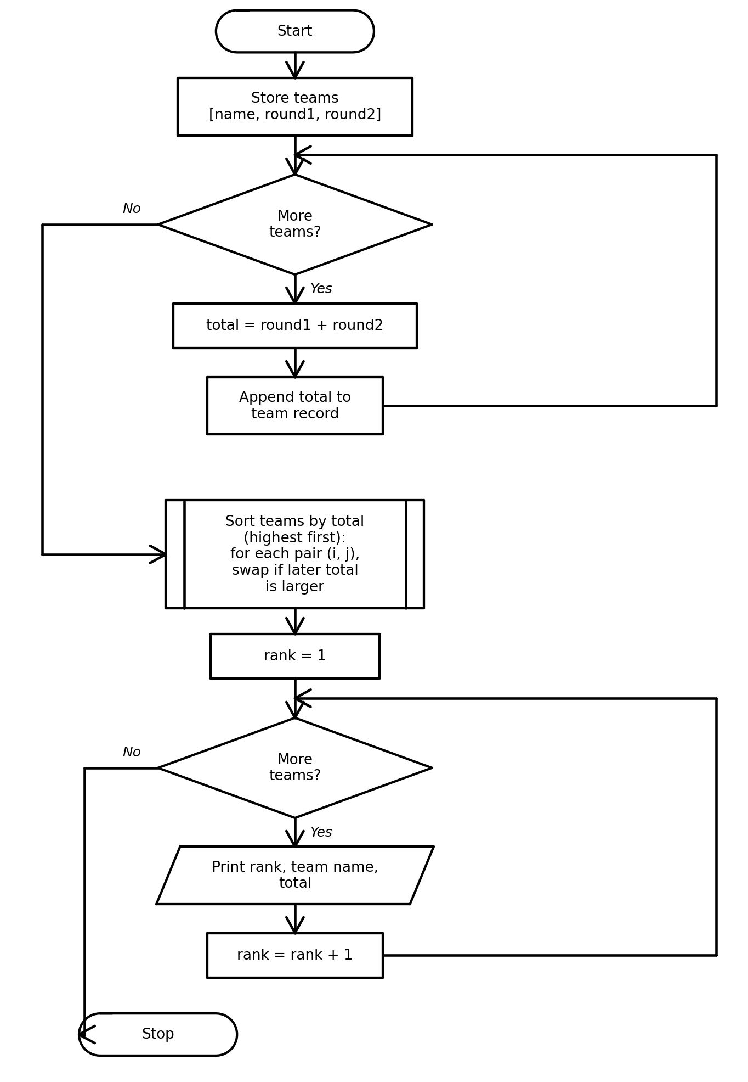

Python Source Code
teams = [
["Team Alpha", 40, 35],
["Team Beta", 45, 42],
["Team Gamma", 38, 41],
["Team Delta", 30, 36]
]
for team in teams:
team.append(team[1] + team[2])
for i in range(len(teams)):
for j in range(i + 1, len(teams)):
if teams[j][3] > teams[i][3]:
teams[i], teams[j] = teams[j], teams[i]
rank = 1
for team in teams:
print(rank, team[0], "Total:", team[3])
rank = rank + 1

Test Cases
Test input / condition | Expected result
Team Beta: 45 + 42 | Total 87; ranks first
Team Gamma: 38 + 41 | Total 79
Team Delta: 30 + 36 | Total 66; ranks last

Program Output
"C:\Users\student\PycharmProjects\pythonProject\.venv\Scripts\python.exe" "C:\Users\student\PycharmProjects\pythonProject\text cases\case9.py"
1 Team Beta Total: 87
2 Team Gamma Total: 79
3 Team Alpha Total: 75
4 Team Delta Total: 66

Process finished with exit code 0

Conclusion
The program calculates team totals and ranks them using nested loops and list operations.

Case 79: Integrated Warehouse Order Prioritization

Problem Statement
Compare product stock with requested order quantities, process high-priority orders first, and calculate fulfilled and outstanding quantities.

Objectives
Practise tuples, tuple unpacking, list sorting, loops, and conditional logic.

Assumptions
Priority 1 is highest. Each record contains product, stock, order quantity, and priority. Stock is allocated in priority order and cannot become negative.

Algorithm
- Store product records as tuples.
- Sort records by priority number, with smaller numbers first.
- For each order, fulfill the smaller of stock and requested quantity.
- Calculate the outstanding quantity.
- Display the fulfillment report.

Pseudocode
START
Store orders as tuples
Sort orders by priority ascending
FOR each product, stock, requested, priority
fulfilled ← smaller of stock and requested
outstanding ← requested - fulfilled
PRINT fulfillment report
STOP

Flowchart
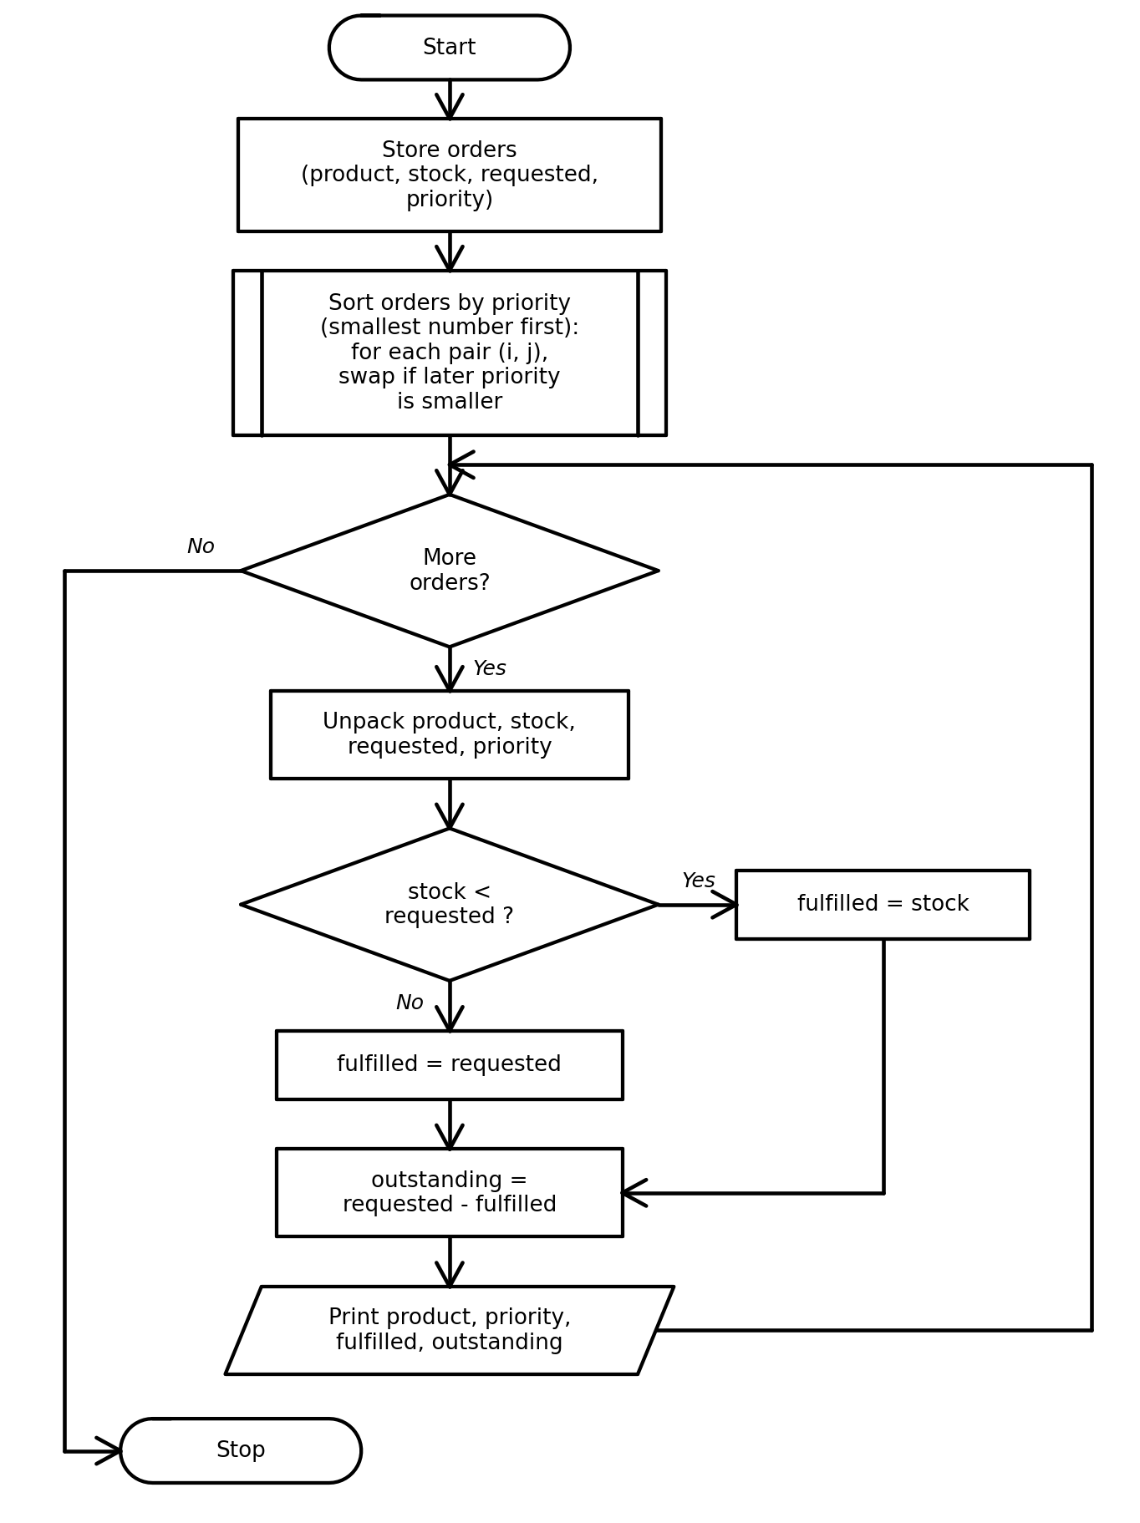

Python Source Code
orders = [
("Pens", 50, 30, 2),
("Notebooks", 20, 35, 1),
("Folders", 40, 15, 3)
]
for i in range(len(orders)):
for j in range(i + 1, len(orders)):
if orders[j][3] < orders[i][3]:
orders[i], orders[j] = orders[j], orders[i]
for product, stock, requested, priority in orders:
if stock < requested:
fulfilled = stock
else:
fulfilled = requested
outstanding = requested - fulfilled
print(product, "| Priority:", priority,
"| Fulfilled:", fulfilled,
"| Outstanding:", outstanding)

Test Cases
Test input / condition | Expected result
Notebooks: stock 20, request 35, priority 1 | Processed first; fulfilled 20; outstanding 15
Pens: stock 50, request 30 | Fulfilled 30; outstanding 0
Folders: stock 40, request 15 | Fulfilled 15; outstanding 0

Program Output
"C:\Users\student\PycharmProjects\pythonProject\.venv\Scripts\python.exe" "C:\Users\student\PycharmProjects\pythonProject\text cases\case10.py"
Notebooks | Priority: 1 | Fulfilled: 20 | Outstanding: 15
Pens | Priority: 2 | Fulfilled: 30 | Outstanding: 0
Folders | Priority: 3 | Fulfilled: 15 | Outstanding: 0

Process finished with exit code 0

Conclusion
The program prioritizes orders and calculates fulfilled and outstanding quantities using tuples and loops.

